**PROJECT OUTBREAK**



A track of corona cases across countries

-by *Shabanu Mathan*

Version 1.0

Date-April 2020

**Table of Summary**

1. **Overview**
2. **Technologies involved**
3. **Relationship between entities**
4. **Table descriptions**
5. **Database objects and descriptions**
6. **Process and data flow**
7. **Reports**

**Overview**

This document targets to demonstrate my expertise in the programming languages I am experienced with. As an example, I have taken the current COVID outbreak in three different countries (India, UK and US) to track the number of cases for 10 days.

Code for all the basic components are manually written and executed using online cloud services. Screenshots are pasted after executing each of the components.

Queries are written in Oracle standards and executed in an online reporting structure to create the reports.

Code is maintained in GitHub service.

**Technologies involved**

|  |  |
| --- | --- |
| **Components used** | **Description** |
| Database | Oracle 12c |
| Infrastructure | Oracle live : <https://livesql.oracle.com/> |
| Programming language | PLSQL and SQL |
| Reporting languages | SQL and Tableau |
| Implementation | UNIX Shell scripting to implement across OS |
| Operating System | Windows and Linux |
| Code base | Git Hub  <https://github.com/mshabanu/outbreak> |

**Relationship between entities and data flow**

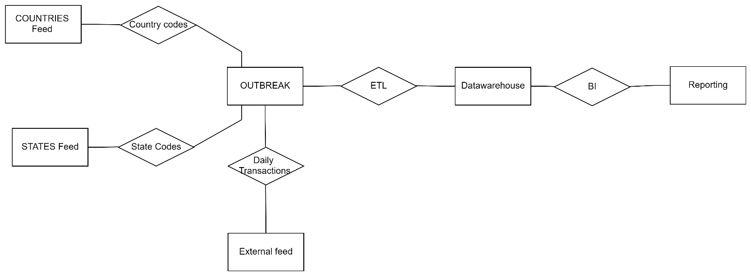**Table Relationships for transactional database**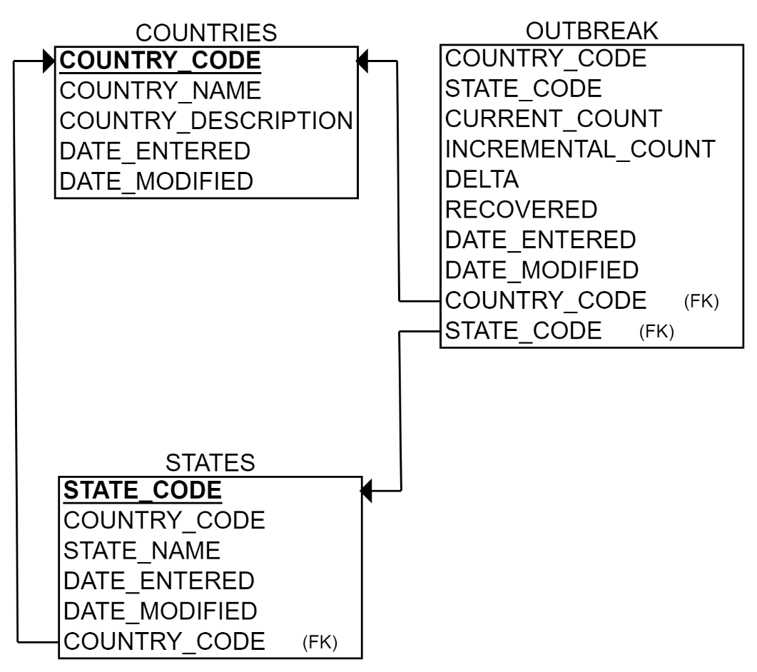

**Table definitions**

|  |  |  |
| --- | --- | --- |
| **Sl. No** | **TABLE NAME** | **CODE** |
| **1** | COUNTRIES |  |
| **2** | STATES |  |
| **3** | OUTBREAK |  |

**PLSQL Packages/APIs to load data from UI/External feed**

|  |  |  |
| --- | --- | --- |
| **Sl No** | **DB Object** | **Code** |
| **1** | **Outbreak Package** |  |
| **2** | **Outbreak Package Body** |  |

**Codebase maintained in the below GITHUB repository. Same has been downloaded and attached:**

<https://github.com/mshabanu/outbreak>



**Code executed in below oracle live database:**

[**https://livesql.oracle.com/**](https://livesql.oracle.com/)

**Proof of code executions can be viewed using the below URL:**

[**https://livesql.oracle.com/apex/livesql/s/j0wf7ebwjyvypdeelt3q22uqg**](https://livesql.oracle.com/apex/livesql/s/j0wf7ebwjyvypdeelt3q22uqg)

**Executed copy of file is downloaded and attached below:**



**Screenshots of code executed successfully in the database.**

**OUTBREAK:**

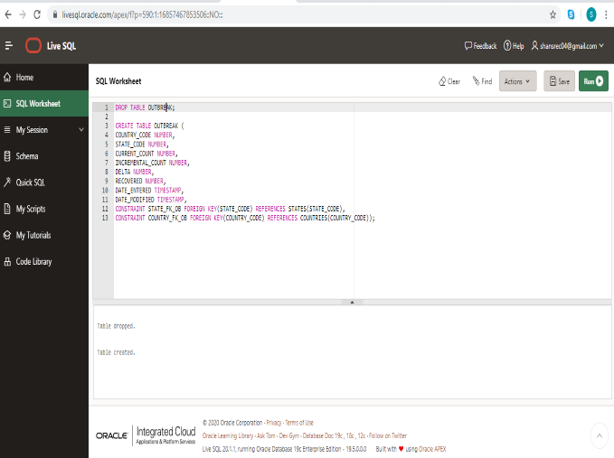

**STATES:**

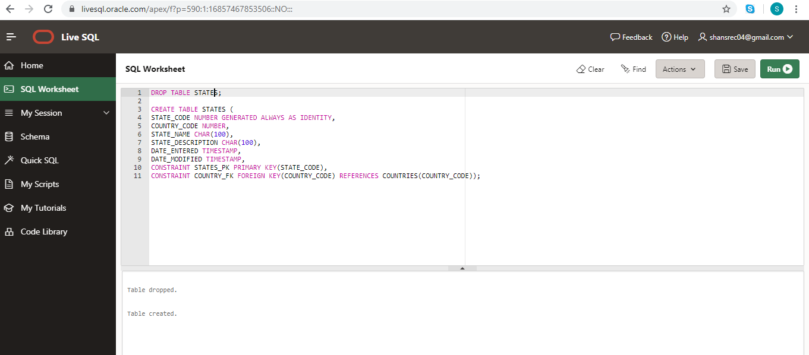

**COUNTRIES:**

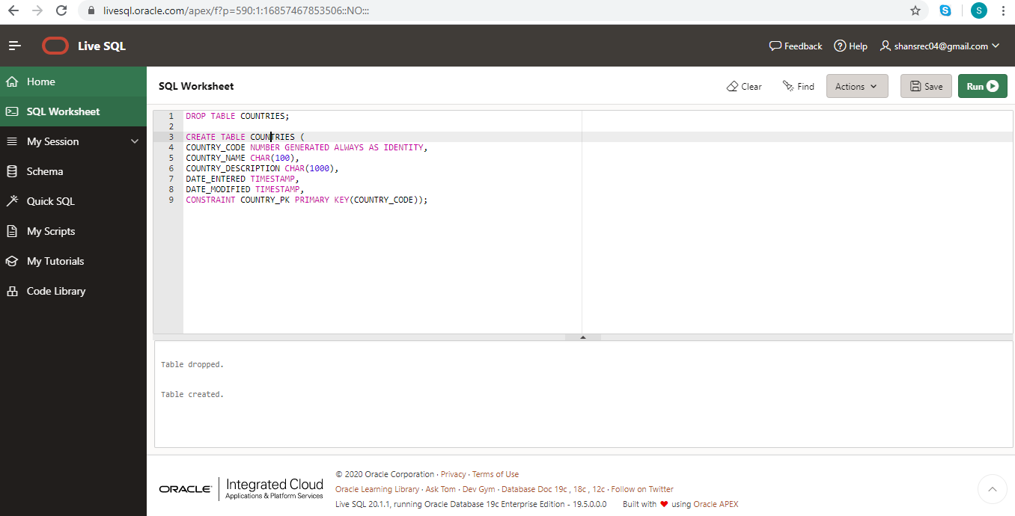

**API for inserting daily data into database.**

**Code PACKAGE**:

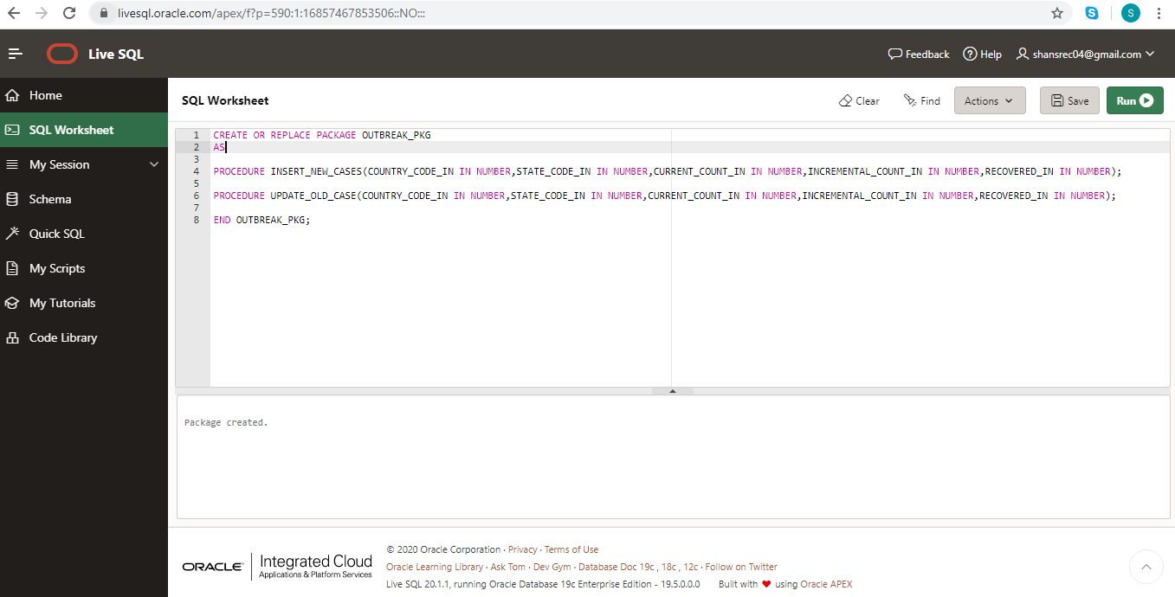

**Code PACKAGE BODY:**

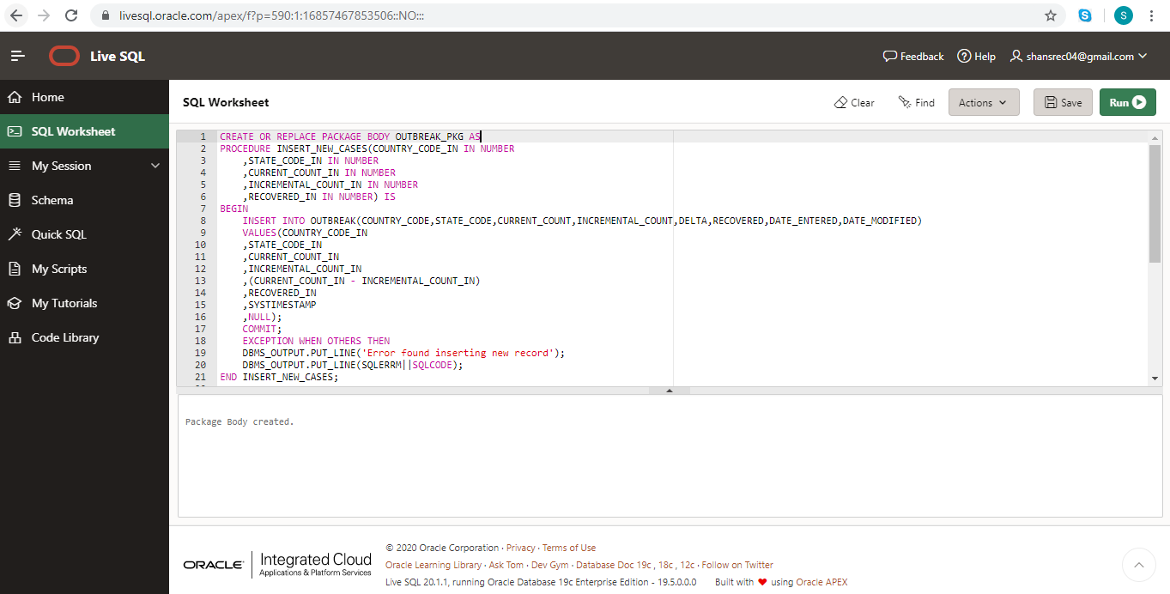

**API executed to insert random data for ten days for three different countries (INDIA, UK and US)**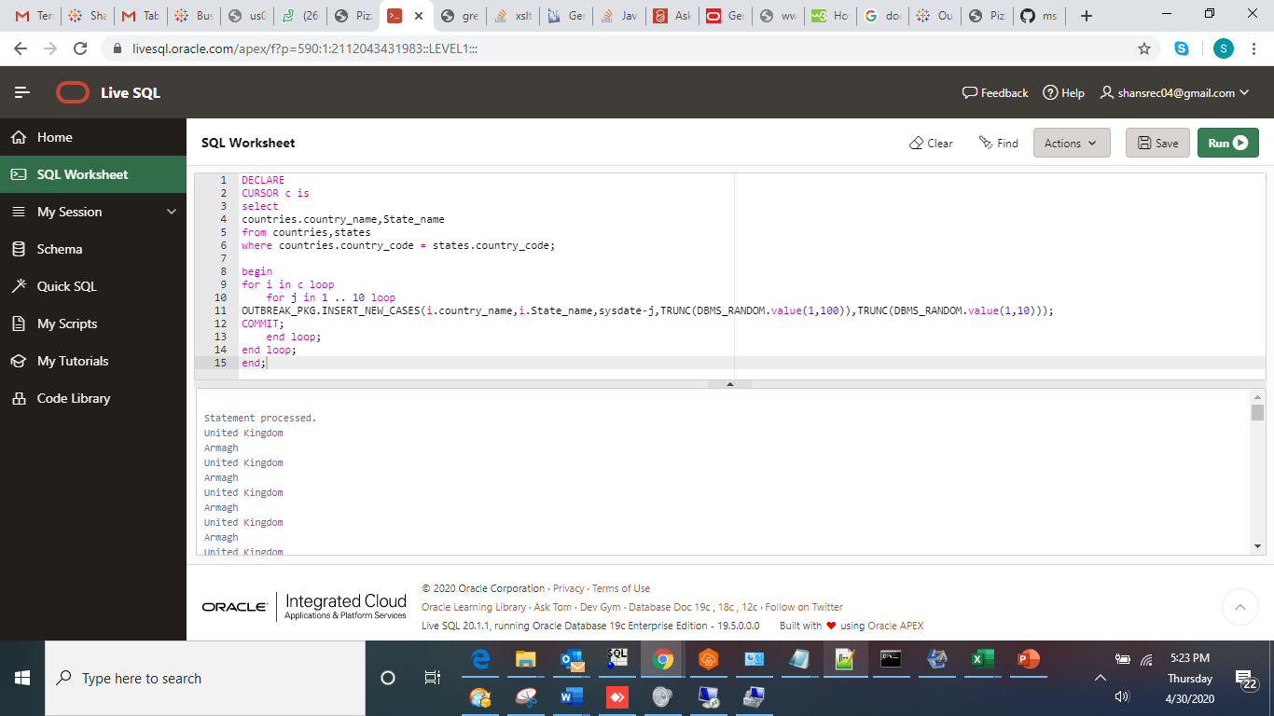

**API Executable file to load transactional data:**



**Report query:**

Below report query can be used in Oracle and equivalent DB to get a grid output.



**Grid output for the query:**



**Alternately Tableau software is used to build report.**

**Below Tableau Dashboard is published online to visualize the report:**

(Note: Valid online login and license is required to see this data)

[**https://prod-apnortheast-a.online.tableau.com/t/personal/views/Outbreak/OutbreakLineChart?:origin=card_share_link&:embed=n**](https://prod-apnortheast-a.online.tableau.com/t/personal/views/Outbreak/OutbreakLineChart?:origin=card_share_link&:embed=n)

**Tableau executable file to view it on a desktop software is attached below:**



**Tableau Report output:**

